DW-ARC40-WJ | DROMEX ARC 40 CAL WINTER JACKETS
- 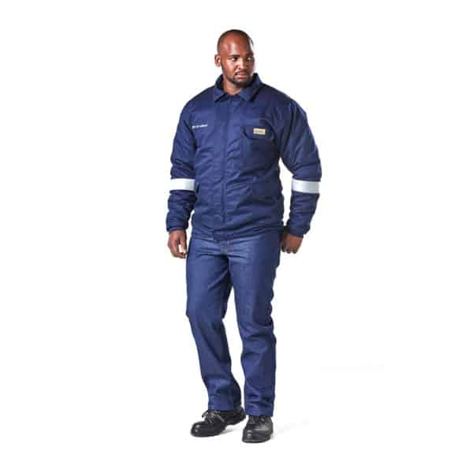

DW-ARC15-J | DROMEX ARC HRC2 - 15Cal JACKET
- 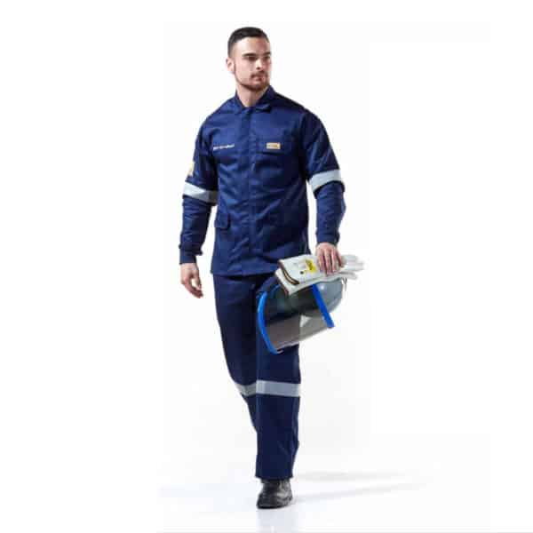

DW-ARC15-P | DROMEX ARC HRC2 - 15Cal PANTS
- 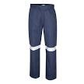

DW-ARC9.9-SST | DROMEX ARC T-SHIRT SHORT SLEEVE, 9.9 CAL
- 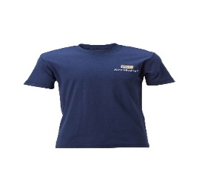

DW-TSHIRTGY | DROMEX GREY 100% Cotton Crew neck tee shirt
- 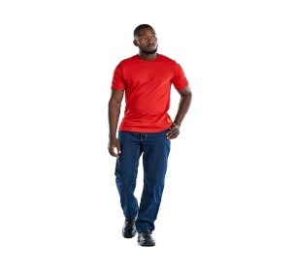

DW-6535XX-J | DROMEX COLOURS "XX" 6535 Polycotton, SANS 434 FIT CONTI Jacket
- 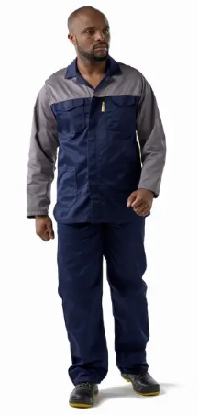
DW-6535XX-P | DROMEX COLOURS "XX" 6535 Polycotton, SANS 434 FIT CONTI Pants
- 
PROMAX | PROMAX white Disposable Overalls
- 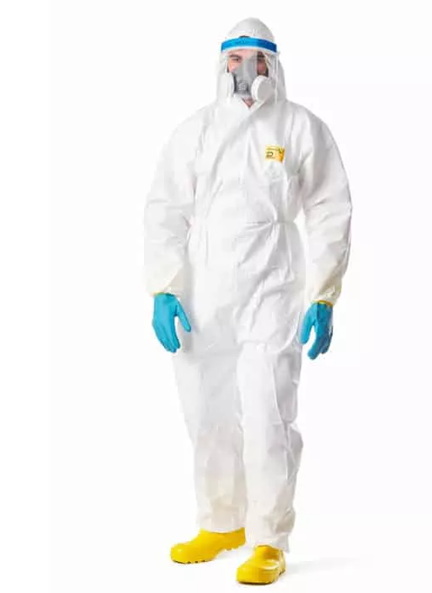

DW-CONTI-RTOR | DROMEX ORANGECONTI SUITS with Reflective
- 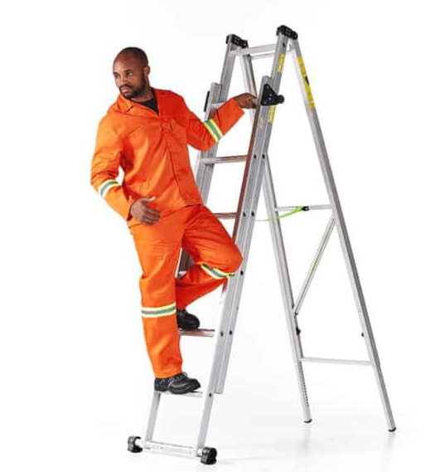

CEM | Classic Muff, SNR 30, Blue
- 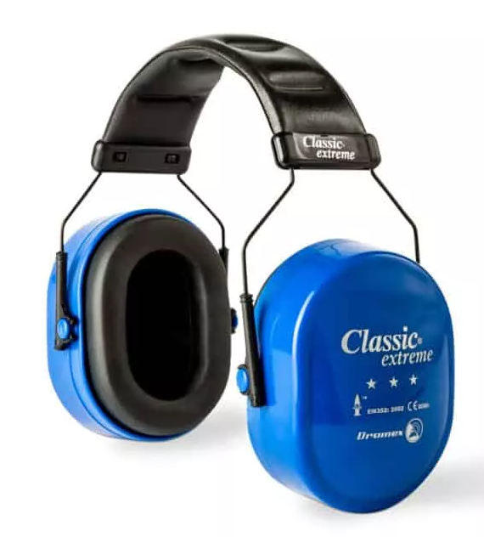

1020 | DROMEX FFP2 (SABS REF: AZ2004/18)
- 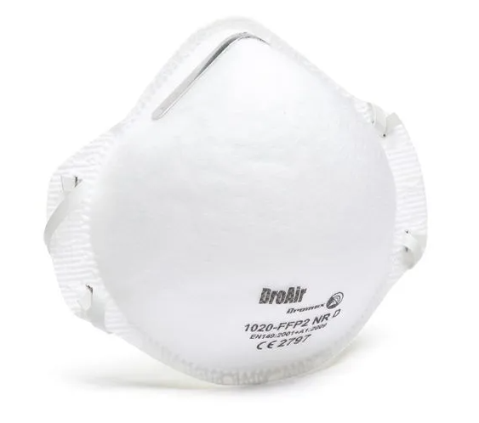
NITRIFLEX-PC | NITRIFLEX Black Sanitized PALM nitrile coated
- 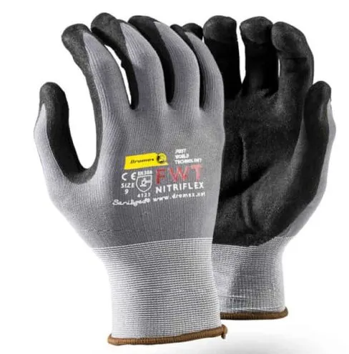

MIIZULFM4001W | MIIZU 400 THERMAL, HI VIZ, WINTER
- 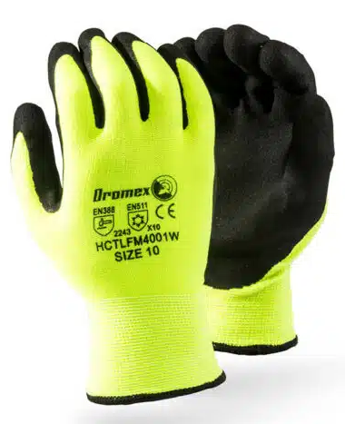

GGOAT | Goatskin VIP, Keystone,
- 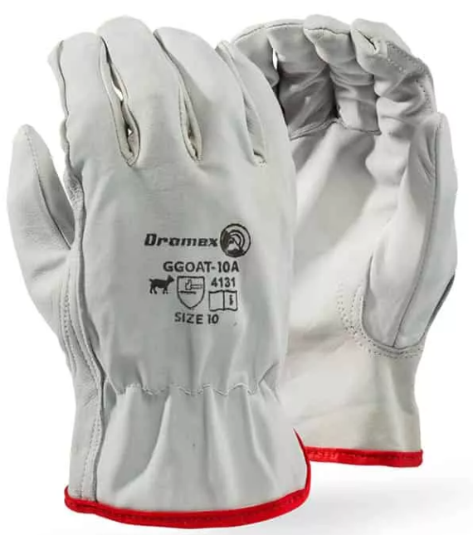

NITRIFLEX-PC | NITRIFLEX Black Sanitized PALM nitrile coated
- 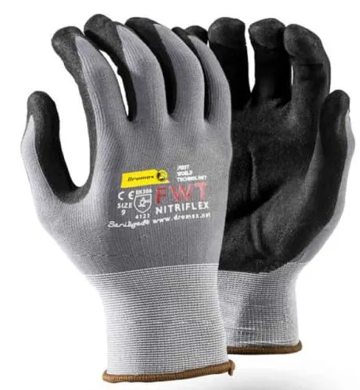

NITRIFLEX | NITRIFLEX Black Sanitized FULL nitrile coated
- 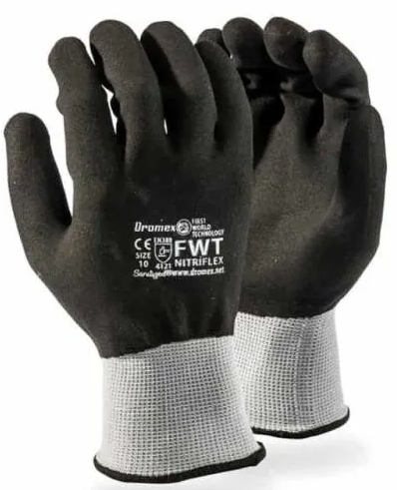

DH-HH-DB | Dromex Hard Hat DARK BLUE (LAMINATION BLUE)
- 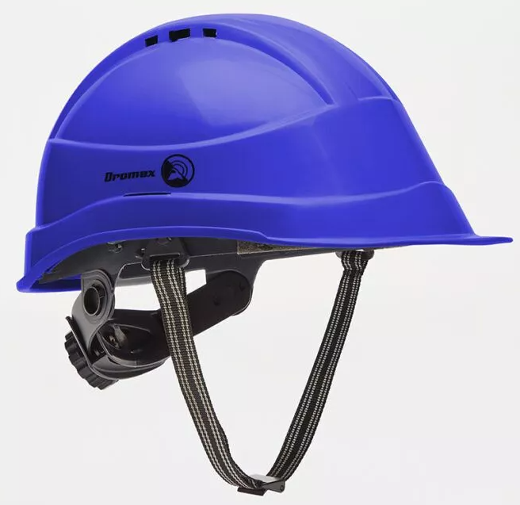

DH-HH-W | Dromex Hard Hat WHITE
- 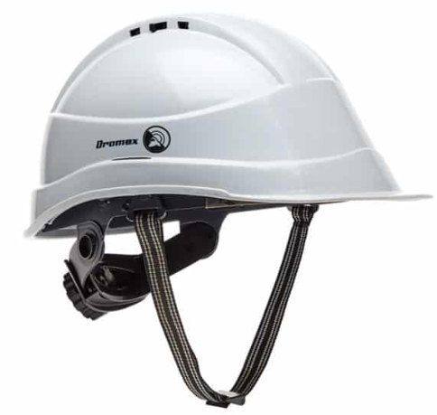

DV-11 | DIRECT MESH VENT (1,F)
- 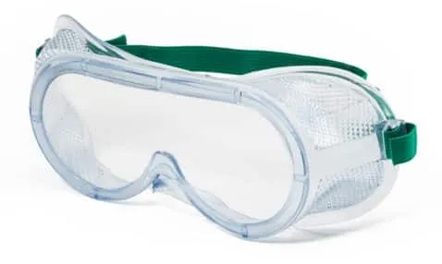

DV-326B-C-AF | SPOGGLE, CLEAR, ANTI MIST
- 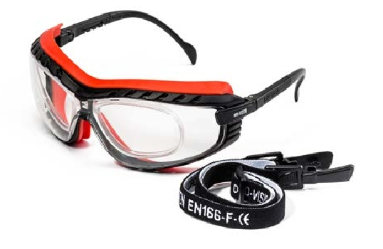

DV-004MAX | IN-DIRECT ULTIMATE VISION, WIDE BAND ELASTIC
- 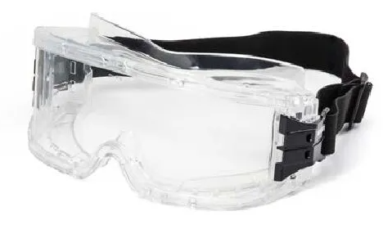

DV-026-IR5 | SHADE 5.0 GREEN, ANTI SCRATCH
- 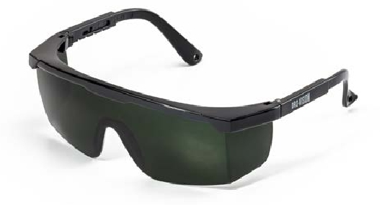

DV-326B-G-AF | SPOGGLE, GREY, ANTI MIST
- 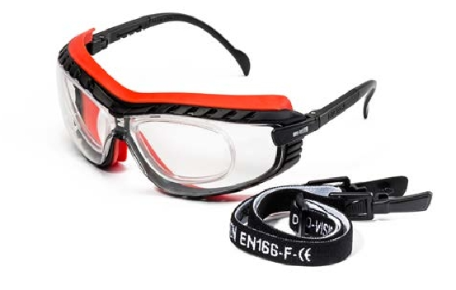

ACE ONE 60x90 | ACE Leather welders apron ,60 x 90cm, ONE PIECE
- 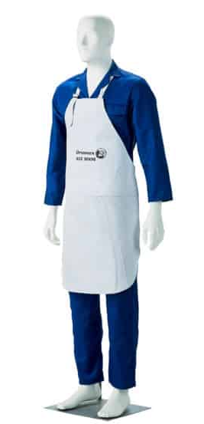
DF-CHELSEA-BLK | DROMEX CHELSEA BLACK BOOT
- 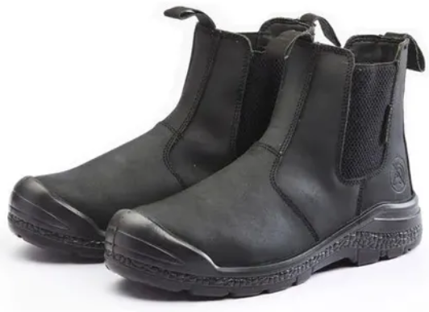

DF-CHELSEA-BR | DROMEX CHELSEA BROWN BOOT
- 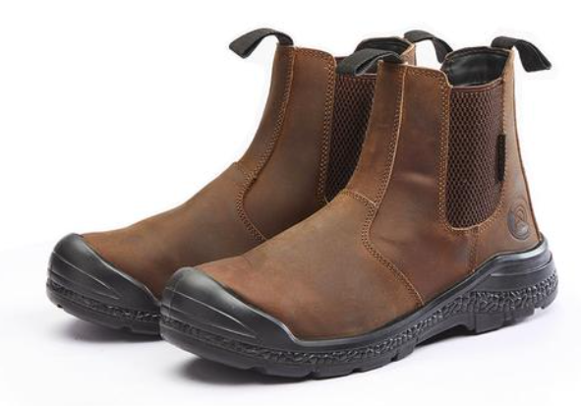

1021 | DROMEX FFP2 V (SABS REF: AZ2004/17)
- 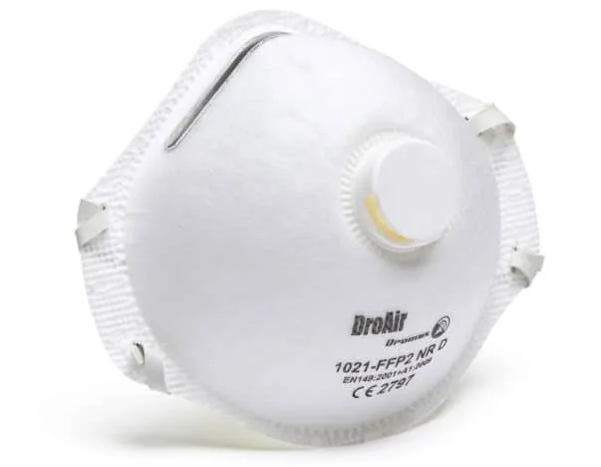

DF-UBLK | DROMEX ULTECO SAFETY BOOT BLACK
- 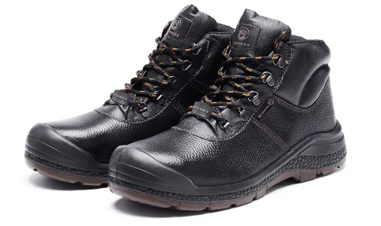

CRONUS/RGE | DROMEX CRONUS RED/GREEN PVC gloves, reinf., elbow
- 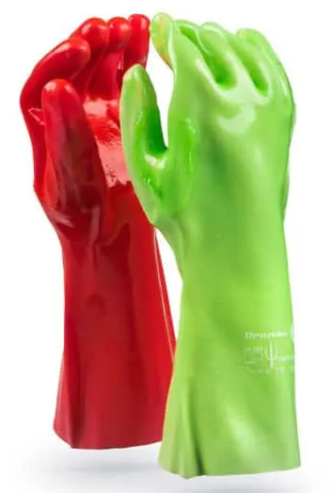

DB-STG-J | DROMEX STORM GLACIER FREEZER JACKET
- 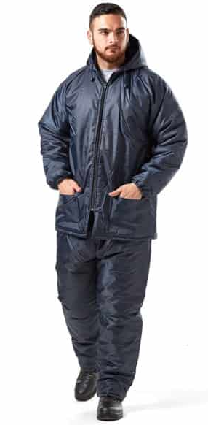
DF-SP-STCM | DROMEX SPARTACUS GUMBOOT, STCM
- 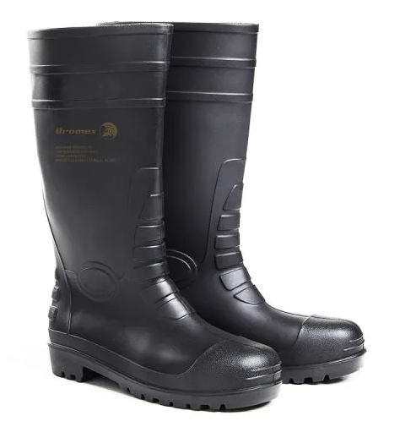

SA10-LIME | LIME Reflective Vest , ZIP, ID POUCH
- 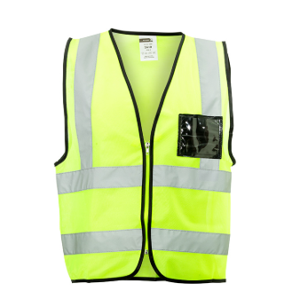

DF-FLASH | DROMEX FLASHTREAD ARC BOOT
- 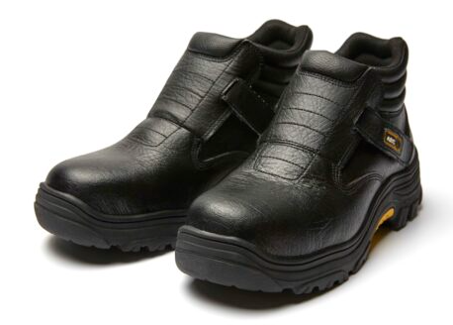

DF-SS1050-BLK | DROMEX BOXER CHELSEA BOOT BLACK
- 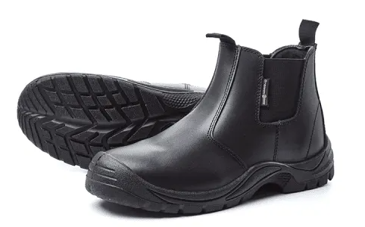

DF-SS1050-BR | DROMEX BOXER CHELSEA BOOT BROWN
- 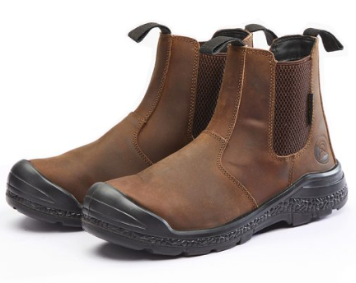
DF-CHELSEA-BLK | DROMEX CHELSEA BLACK BOOT
- 